|  |  |  |  |  |  |
| --- | --- | --- | --- | --- | --- |
|  |  |  |  |  | logo1.png |

|  |  |  |  |
| --- | --- | --- | --- |
| Course Name | | Zoho Books | |
| College Name | | Mangayarkarasi College of Arts and Science for Women Paravai, Madurai - 625002 | |
| College Code | | MKU251 | |
| Skill Offering Id | |  | |
| Project Title | | Preparation and maintenance for accounts of fresh bites catering | |
| Project Submitted To | | Madurai Kamaraj University ( Naan Mudhalvan Scheme(TNSDC)) | |
| Year | | 2023 | |
| Department | | B.COM | |
| Semester | | 5 | |
| Group Number | | 5 | |
| Total Members of the Group | | 4 | |
| Group Members Details | | | |
| Name of the Member | University Register. No | | Student NM ID |
| T.ABARNA | C1C15851 | | F0D4AEEE1764319AD4E45C19AF54B9FB |
| M.DHIVYADURGA | C1C15864 | | 91DBB563FCAD86391964BCDB3D8AA4AD |
| P.MUTHUVALLI | C1C15882 | | 5CD24E4953053578EF74812CDEA4D376 |
| M.JANANI | C1C15868 | | A6F282B8FDF8D16974B44B15F77BC93B |
|  |  | |  |
| Under the Guidance | |  | |
| SPOC | | Ms.P.UMADEVI | |



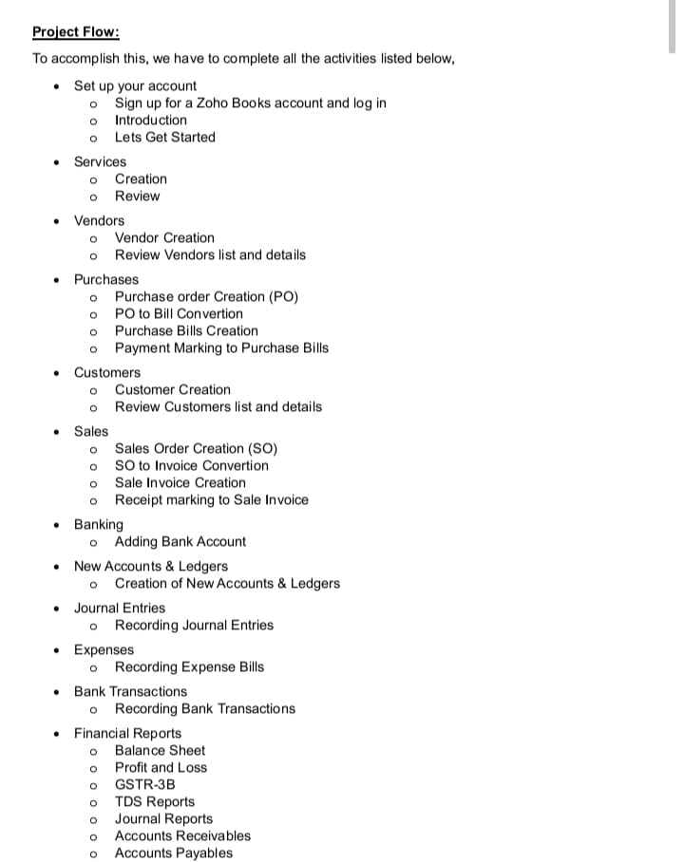

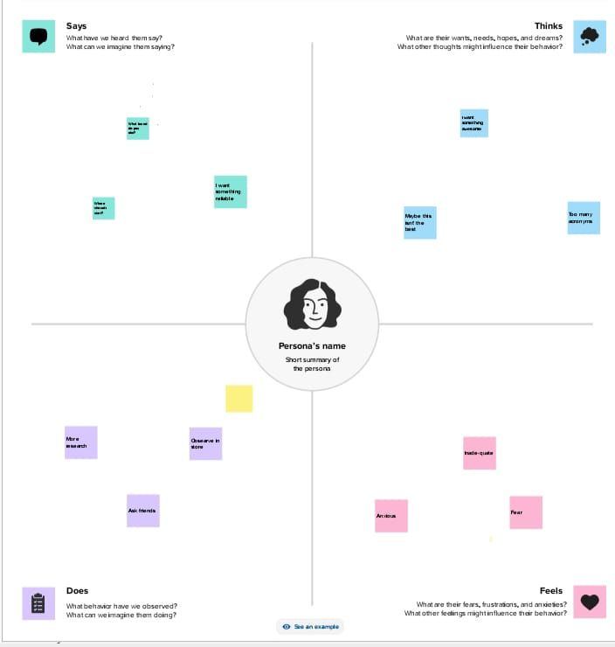

**2.2 Ideation and Brainstroming Map**

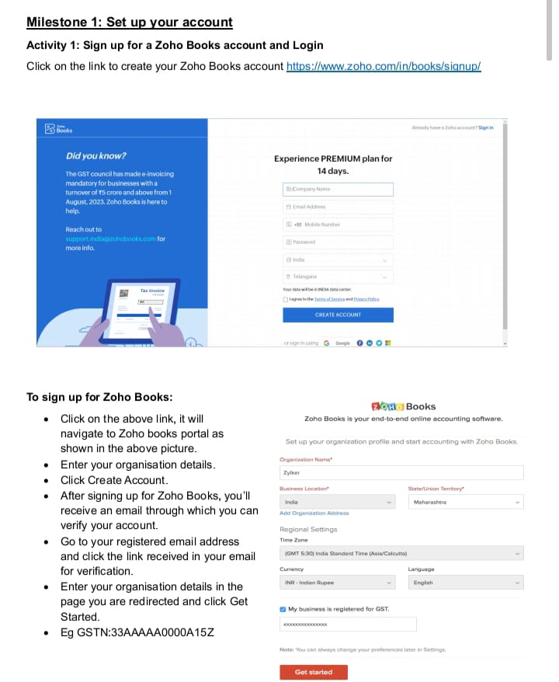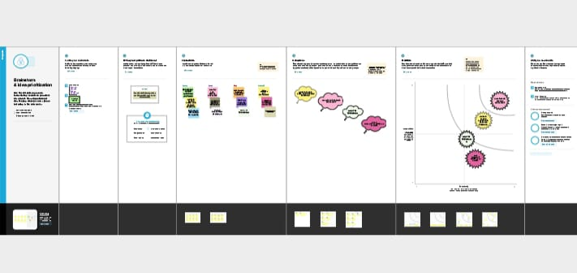

1. **Result:**

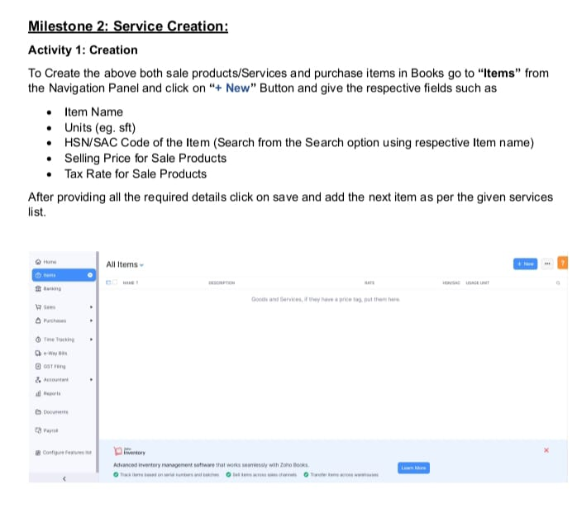

**Prices of Houses based on Area :**

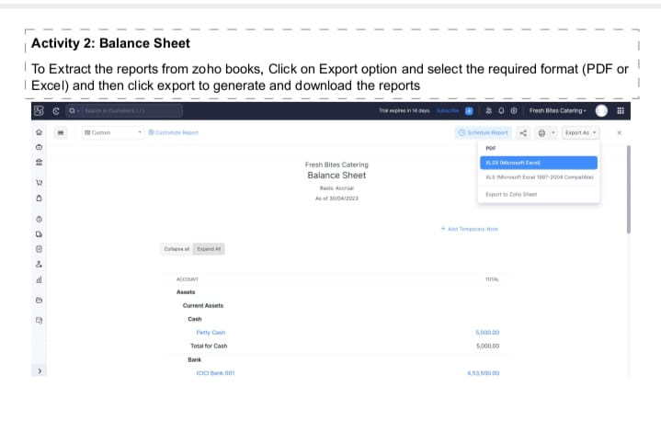

Milestone 1: Set up your account

Activity l: Sign up for a Zoho Books account and Login

Click on the link to create your Zoho Books account

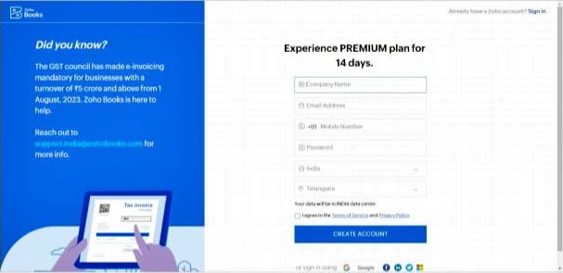

TO sign up for Zoho Books:

* Click on the above link, it will navigate to ZOh0 books portal as shown in the above picture.  Enter your organisation details.  Click Create Account.
* After signing up for ZOh0 Books. you 'Il receive an email through which you can verify your account.
* GO to your registered email address and click the link received in your email for verification.
* Enter your organisation details in the page you are redirected and click Get Started

Eg GSTN:33AAAAAOOOOA15Z

**House Price based on Rain Water pits:**



**Vastu – Complaints based on location:**

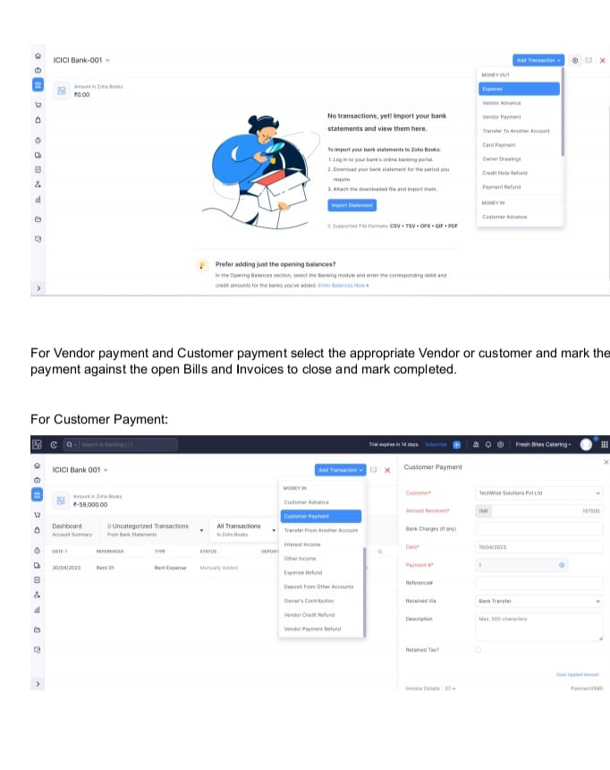

**House price based on Number of Bedrooms :**

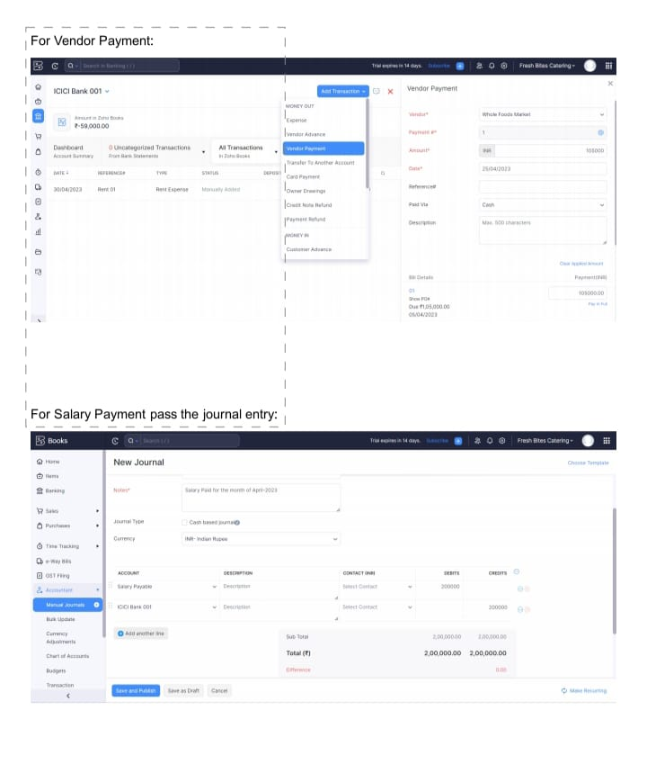

**House price based on nearby schools and hospitals:**

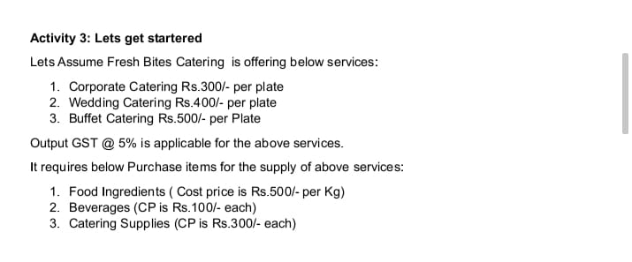

**Maintain staff in houses prices:**

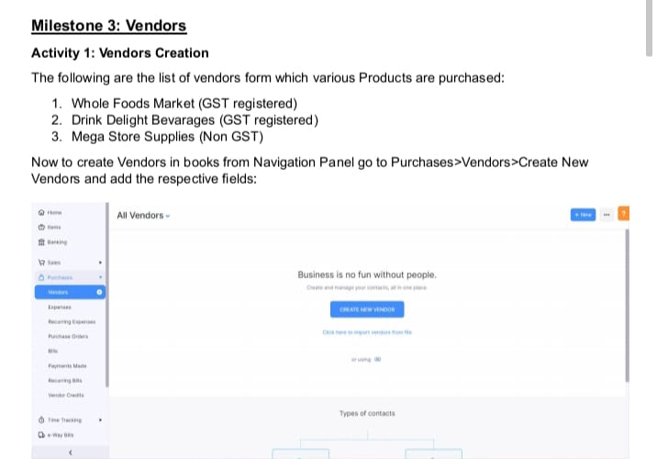

**House Price and Intercom:**

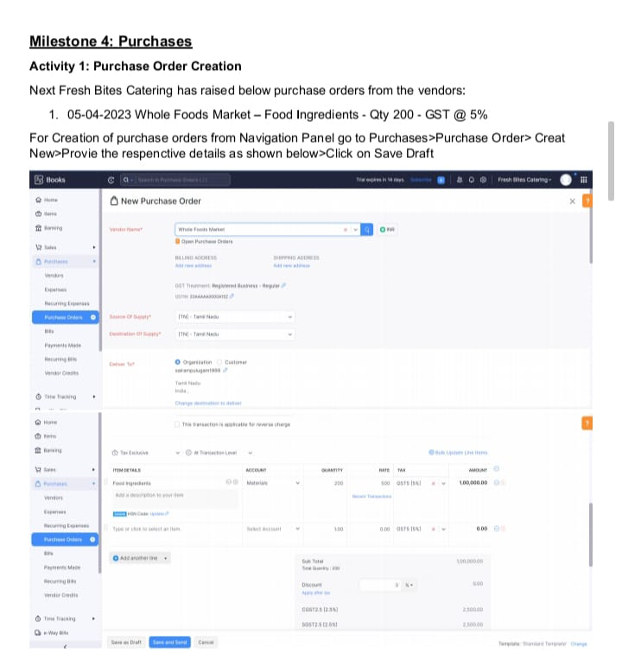

**All services based on locations:**

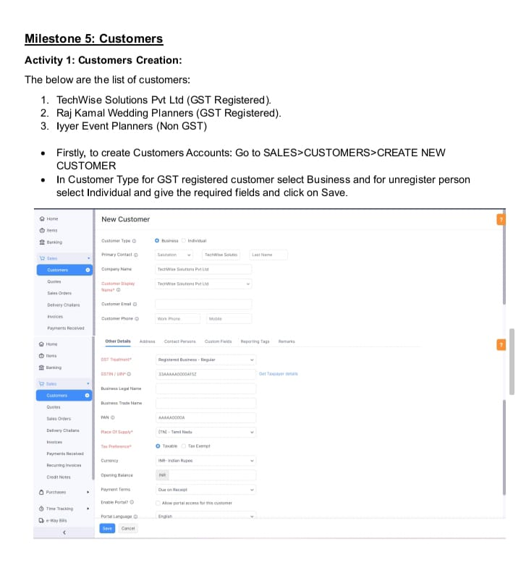

**Dashboard 1:**

**Dash board 2:**

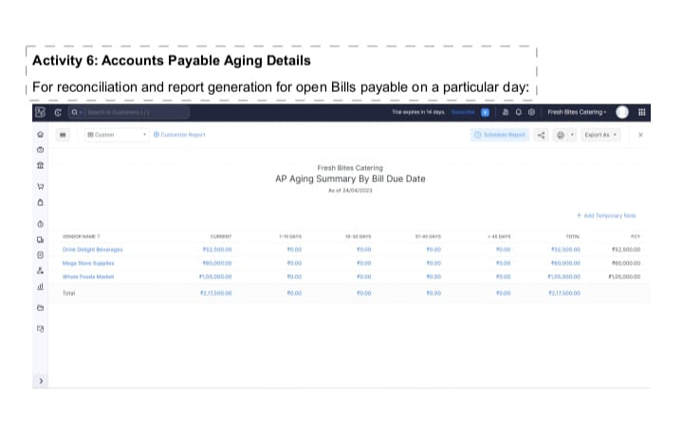

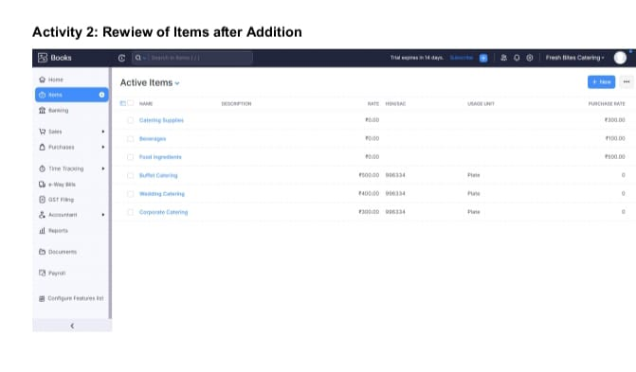

**Dashboard 3:**

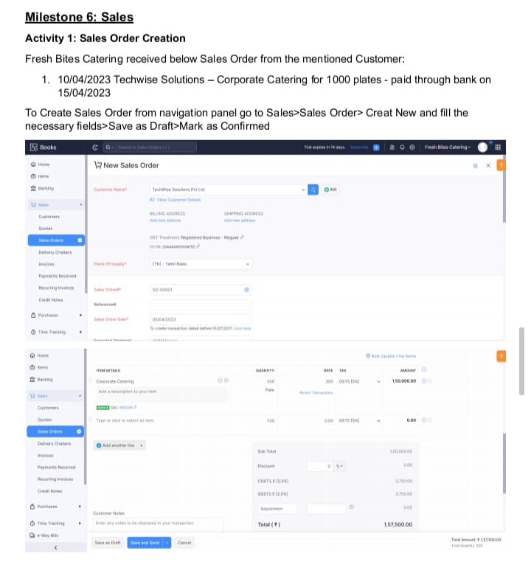

**Story 1:**

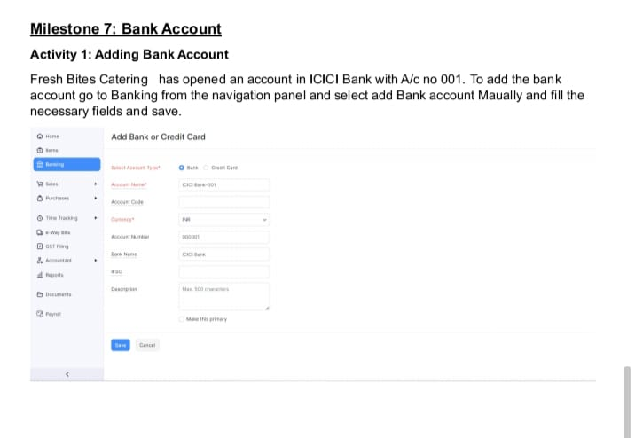



**Story 2:**

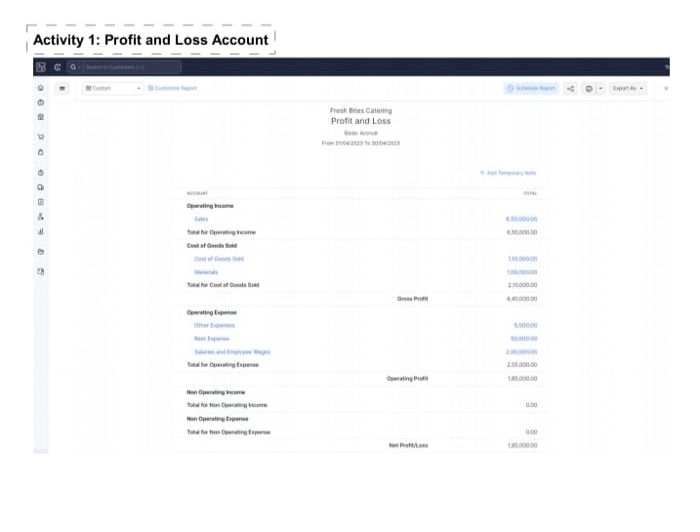



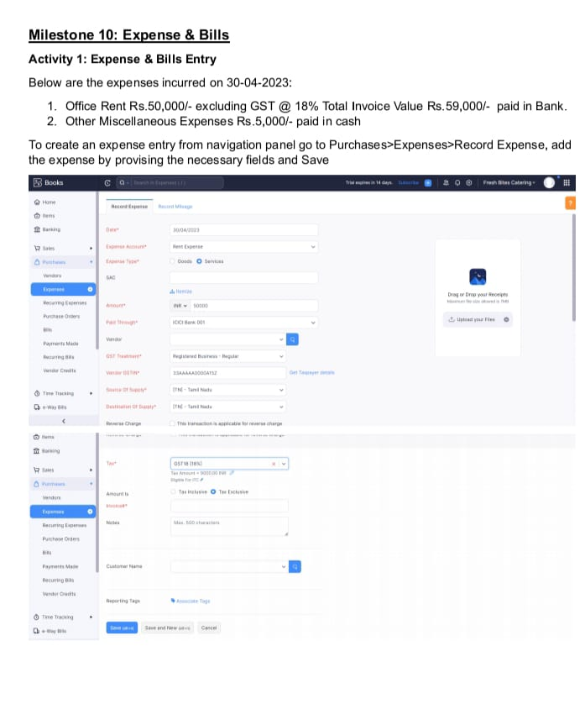



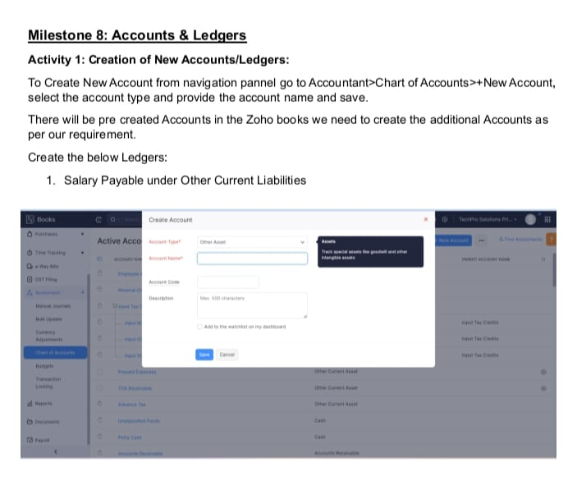

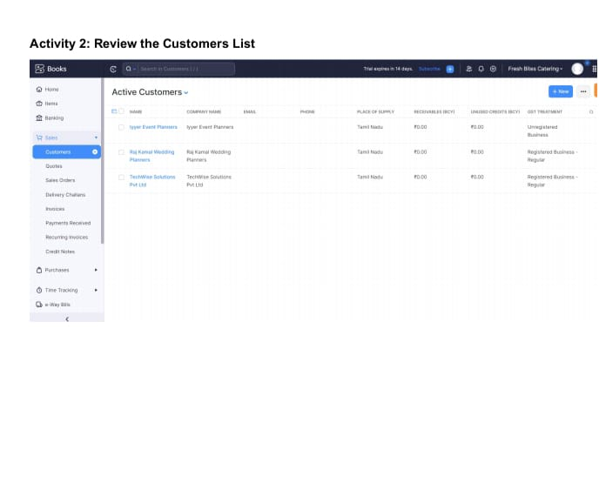



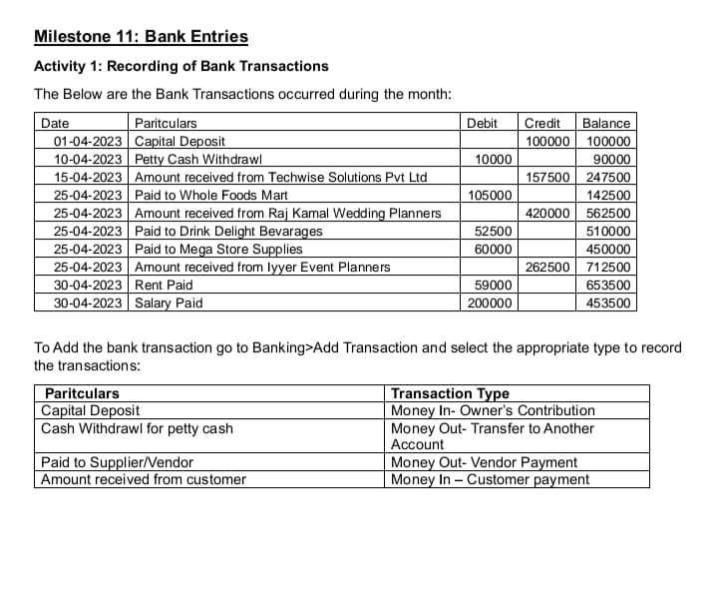

***4. Advantages :***

* **Market Transparency:**
  + - * **Regular analysis of housing prices promotes transparency in the real estate market, reducing the likelihood of fraudulent practices.**
* **Economic Growth:**
  + - * **A stable and thriving real estate market can stimulate economic growth market can stimulate economic growth, creating jobs and driving investments in related industries.**
* **Quality of Life:**
  + - * **Access to suitable housing enhances the overall quality of life for residents, contributing to their well being and satisfaction.**

***Disadvantages:***

* **Inequality:**
* **Housing price disparitites can exacerbate wealth and income inequality, creating social and economic challenges.**
* **Exclusionary Effects:**
* **Rapid price increases can lead to gentrification, pushing out lower income residents from desirable neighborhoods.**
* **Environmental Impact:**

1. **Conclusion:**

ln conclusion, the analysis of housing prices in metropolitan areas serves as a multifunctional tool with wide ranging applications. It plays a pivot role in shaping urban landscapes, economic development, and individual choices, while also serving as a critical resource for policymakers and researchers. Recognizing the advantages and challenges associated with housing price analysis allows for more informed and responsible decision making in the complex world of real estate and urban development. The examination of housing prices serves as a vital tool for understanding the dyn market and itamics of the real estate market and its broader impact on society and the economy.

1. **Future scope:**

In the future, several enhancements and improvements can be made in the effective. Some potential enhancements include, Advanced Data Sources, Machine Learning and AI, Real Time Data, Predictive Analytics, Visualization Tools, Integration with Other Data, Affordability Metrics, Mobile Apps. These enhancement can help make housing price analysis more accurate, relevant, and beneficial for a broader range of stakeholders, ultimately contributing to more informed decision making, equitable urban development and sustainable housing solutions in metropolitan area.